COMP 3008: Human-Computer Interaction

Assignment 3

**Ryan Lo (101117765)**

**Grading**: Score out of 100 (Question 1: 70 points, 2: 25 points, 3: 5 points)

**Due date**: Wednesday, October 19 at 11:59 pm on Brightspace

**Lectures covered**: 8-10

**Format:** Please use Times New Roman size 12 font and normal margins

**Submission**: Submit a PDF with your name in the following format: “Lastname_Firstname_A3” **Plagiarism warning**: this assignment is to be done individually (although you may recruit other students in class to answer the survey)

# Preface

For this assignment, you can use the same interface and task that you had used for Assignment 2. However, if you would like to choose a different interface or different task that is fine as well. It is completely up to you. However, please note that it would be helpful to stick to the same interface moving forward to Assignment 4, where you will need to suggest improved designs for your interface. You will still be allowed to change if you wish, but it might make things slightly more difficult for you. So consider your choice carefully for this assignment.

# Software needed

*Survey*: You can use Google forms, a basic (free) version of Survey Monkey, or any similar platform of your choice. You can also create a document and then use it as a survey, but that might make the deployment and analysis slightly more involved.

*Task analysis*: You can work with any software you like to carry out your task analysis. You can use Google Drawings, trial versions of Visio, Lucidchart, XMind, or any similar applications, or do it in Word, Powerpoint, etc. Pick whatever option you like to ensure that your task analysis is clear and readable. Consider using landscape orientation if needed.

**Question 1** *70 points | 5 points unless indicated | Lectures 8, 9*

1. Indicate what **interface** and **task** you have selected, provide a picture/screenshot, and indicate whether they are the same as the ones you picked in Assignment 2. If one or both are not the same, explain why you made that change.

The interface that I selected is going to be the same one as the one I picked in Assignment 2. The task that I selected which is to use the car dashboard and use a navigation app to navigate to school will also be the same as the one I picked in Assignment 2.

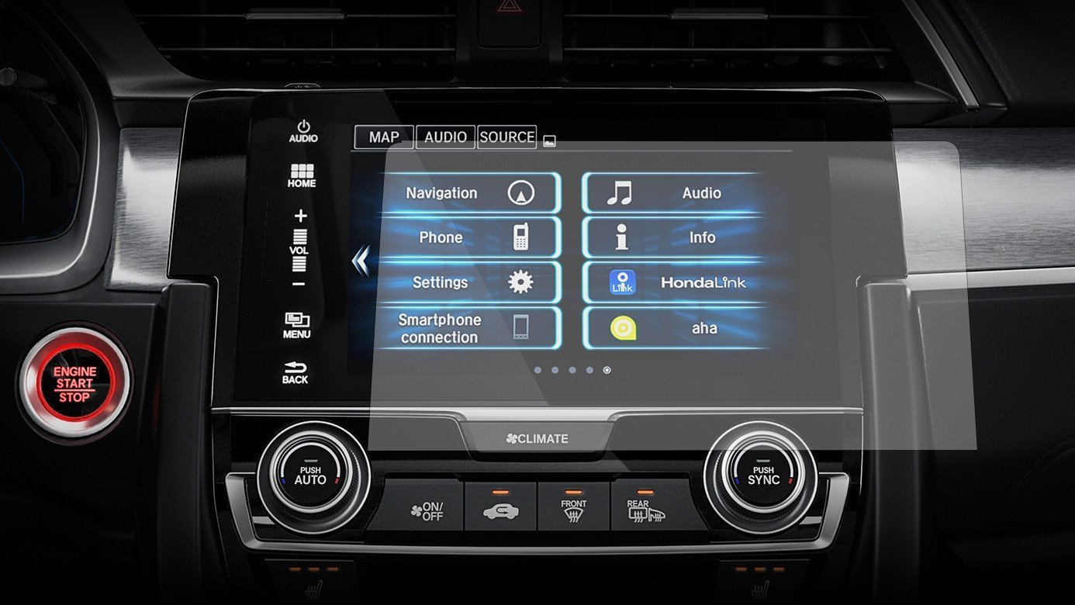

1. Carry out a **cognitive task analysis** (CTA) for your selected task (carry out additional observations or interviews if you need to, especially if your interface/task is new, but there is no need to report on those)
   1. Present your CTA as a tree, making sure to indicate your starting assumptions and level of detail (10 points)

Starting assumptions is that user has the phone ready and a cable to connect to the car. Knows how to use a touchscreen.

* 1. Which of the cognitive functions present do you think is the most time consuming, and why? Explain using design or cognition concepts.

I think that the most time-consuming cognitive function that is present is the search for the desired destination. Most of the time, results are really similar to each other because there could be multiple of the same name for the destination showing up. The design of the menu for the searching a destination is a lot of the time hard to see due to same design for each option which is an example of salience.

* 1. What key information or insight can you get from your CTA? It could be a problem that you detect, a possible design change, a potential error, etc.

Some key information that I can get from my CTA is that there are going to be many issues that can occur with this interface. The interface itself is not perfect and could have malfunctions pretty often such as cable disconnecting which will require the user to reconnect it and start all over or the internet connection is unstable which will not allow it to load the navigation.

1. Create a **survey** with 7-10 questions in total that you will administer electronically or in writing to two people you know. All questions must be closed-ended (you can include an “other” option if needed), but the type of question/scale is up to you. The survey must be tailored to your particular interface (i.e., you cannot use a well-known survey).
   1. Indicate the goal(s) of your survey, whether the two people participated in Assignment 2 in any capacity, and whether you did any additional observations before you asked them to fill the survey.

The goal of my survey is to understand the interaction between users and the interface and how accessible it is.

* 1. Create a well-designed survey to target your goals and provide the link or your questions (*make sure the link works* if you provide that; 10 points)

<https://forms.gle/yqTiWcyUW6G8jNMD8>

* 1. Summarize all the results from the survey using clear graphs or tables (it will not be meaningful for two people, but it is ok!). These can be generated from your platform or ones you create, as long as each figure or table is properly labeled (e.g., Figure/Table 1: Respective question(s)). Any axes should also be labeled.

* 1. What insight did you get from your survey? Discuss while referring to figures/tables, as appropriate, and tie everything back to your goal(s).

What I got from my surveys were that the software itself was pretty simple and straightforward to use. It didn’t have any issues in terms of functionality. It’s pretty accessible for new and existing users. It just had some minor things that it could touch up. Tying it back to the goal, it was easy to use and accessible for any users.

* 1. Informally ask the two people who filled out your survey for feedback. For example, did they find any questions confusing? Discuss any feedback you obtained and explain how/if you would update your survey.

User thought it was fine. Just very surface level questions. Easy for people that don't know anything about the interface to understand. Questions could ask more like in depth questions if it were a real survey in order to like gauge and improve a product though. I would try to make the questions more detailed and open ended to get a better representation of what could be improved.

1. Create one primary **persona** for your interface that is based on everything you have done so far (again, carry out additional data gathering if needed, but no need to report on that).
   1. Your persona should take up around half a page up to one page at most, and needs to be clear, thorough, and well organized (put a placeholder for an image but no need to put an actual image; 10 points)

* 1. Explain how the main elements of your persona were derived (e.g., from which data gathering approach, from your experience, your goals, etc.) and how it might help you moving forward to the design phase.

My persona was derived from all of my previous data that I’ve collected. The about section comes from what my task was for the user. Goals show the goals that were created for getting data for this task. The other sections comprise of the interview data and the surveys. Feedbacks from how the software and interface interacted was also used for the persona.

**Question 2** *25 points | 5 points unless indicated | Lecture 10*

1. Go through the Nielsen, Shneiderman, and Wickens **design principles** systematically and evaluate whether those are met in your interface. You can focus just on your one selected task or look at the whole interface, whatever is most meaningful in your context. Whether the principle is met or not, you have to briefly explain why or why not with a specific example. If the principle is not applicable to your design, explain why. If you feel any principle is redundant, mention that and say “refer to [other principle]” (15 points).

**Wickens’ design:**

Perceptual principles

The interface itself is legible, you can see thing clearly

The maps application avoids absolute judgement limits with the darker shade to indicate not drivable and lighter ones so show where you can drive

The top down processing could be worked on a bit, it’s hard to see results when searching for destination

Redundancy gain is present with the visual and auditory notifications

Discriminability is somehow shown but could be improved on like how some things look alike on the interface and sometimes hard to discern

Mental model principles

Pictorial realism is shown really well with the map applications showing how it should look like

Attention-based principles

It does a really well job of minimizing information access cost, with the simplest and easiest way of indicating what things do

Proximity-compatibility principle is present, things are close together and don’t have to look all the way to the other side of the display for information

Multiple resources is used but could be improved, it provides both visual and auditory but could incorporate tactile as well

Memory principles

Predictive aiding is definitely present with maps showing you where to go next

The interface does put knowledge in the interface rather than forcing people to keep it in memory

The interface itself has lots of consistent use of colors, symbol, etc…

**Shneiderman’s design principle**

Interface is consistent throughout

Users are able to make shortcuts to applications or quick access navigation

Interface offers informative feedback if something is wrong

It has support for error prevention, if you chose the wrong destination you can go back and pick it again

The user is always in control of any actions if you need to change anything

Does not require the user to memorize any sort of information at all

Design dialogs to yield closure is shown whenever the application is calculating for the fastest destination

**Nielsen’s design principles**

The interface always shows what is happening for the user, any issues or if it’s working

It matches the system to the real world maps

User is always in control of what to do and where to go

It avoids any irrelevant information on the screen, only shows what’s needed

Provides any help needed for the user

1. For any *two* of the design principles that are violated, explain how you could **improve that design**. Be specific and make sure to use concepts we have learned. If you do not have two that are violated, provide any alternative designs that work in your context.

Multiple resources could be improved with tactile buttons to show that the buttons have been pressed. The top down view could also be improved when searching for a destination, it should be more clear on where the destination is and separate each destination from one another.

1. Imagine that it is 50 years in the future and you are trying to create the next generation of your interface/item (if it still exists!). Think of a radically different design and provide any type of **conceptual model** for that design. Indicate what type of model you went for, explain what your new design is like, and highlight how it overcomes some design flaws.

A new generation of my interface that I chose could be Augmented reality. Instead of the car dashboard being off to the side it would be embedded into the front window of the car itself. The front glass of the car would be the display it self showing you all the navigation and arrows showing you exactly which direction to take. The type of model would be paradigms. It shows how the technology in cars and real life practices have been adopted over time. Some design flaws that it could overcome is multiple resources, because the dashboard is usually to the side of your vision, it’s harder to see than if the information needed is on the front window itself already.

**Question 3** *5 points; Lectures 8-10*

**Reflect** on what you have done in this assignment. To help you think, consider the questions provided below. Your answer should be one or two insightful paragraphs and you need to elaborate on at least *two* of these questions.

* This was essentially a pilot study; what would you have done differently if you were doing a full study in real life and had more time and options?
* Looking back at Assignments 2 and 3, how would you have set up your data gathering approach in real life? Consider the techniques used and the sequence of their use.
* How useful were the techniques used here, including surveys, task analysis, personas, design principles, and conceptual models?
* Would you have done a hierarchical task analysis (HTA), rather than a CTA? Do you think the CTA added value?
* How would you have designed your survey differently if not for the constraints given here (closed-ended questions and 7-10 questions)? Would you have used a well- established survey (e.g., SUS, NASA-TLX, etc.)?
* What additional analysis could you have done with your survey if you had collected a more meaningful number of participants?
* How would you have tested the validity or reliability of your survey? Indicate what questions you would have used to that end.
* If you used the same interface for both Assignments 2 and 3 and now wanted to triangulate your results, do you see a clear conclusion emerging or do you have conflicting results?
* What did you learn from this assignment that you had not realized from class?

**This was essentially a pilot study; what would you have done differently if you were doing a full study in real life and had more time and options?**

If this was a full study in real life, I would’ve definitely spent more time collect data. This includes users doing the tasks, interview as well as surveys. I would have changed the task a bit and made it more in depth. I would have spent more time thinking about better questions, creating better interviews and surveys for the users. I would’ve used more opened-end questions than closed-end questions to get better feedback.

**If you used the same interface for both Assignments 2 and 3 and now wanted to triangulate your results, do you see a clear conclusion emerging or do you have conflicting results?**

I’ve used both the same interface for Assignments 2 and 3. I see a clear conclusion emerging. The interface is easy for users to learn and use whether or not they have used an interface like that before or not. The interface itself is simple and user friendly. Does everything it needs to well with some small adjustments that could be done to make it more smooth but overall good interface from the results.